What’s In Your Blood
RED BLOOD CELLS
Red Blood Cells carry oxygen (air) to all the cells in your body. The heart pumps them to all parts of your body. The red blood cells are shaped like little doughnuts without holes. They make up about 45% of your blood. On the surface of your red cells you will find antigens which are responsible for the different blood types: A, B, AB, and O.

WHITE BLOOD CELLS 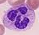
White Blood Cells are larger than red blood cells but we have less of them in our blood. They make up less than 1% of your blood. White cells are soldiers of your body and protect your body against germs and fight diseases. If you get sick, your body will make more to protect you.
PLATELETS
Platelets are the smallest blood cells. They help stop bleeding if you get cut. They stick together and make the scab for healing. They make up 5% of your blood.

PLASMA
Plasma is the yellow watery part of blood. All blood cells float in this liquid which carries proteins and nutrients to all parts of your body. Plasma makes up more than 50% of your blood and it gives you energy.

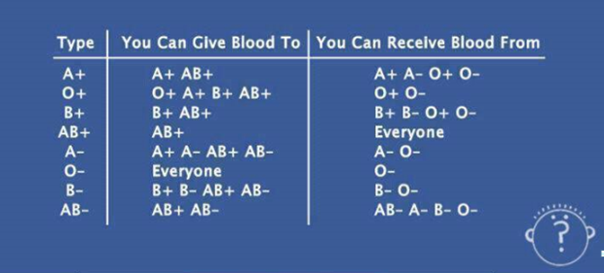
BLOOD TYPES
There are 4 blood types determined by the presence or absence of 2 proteins on the surface of blood, the A & B antigens.
- Group A – has only the A antigen on red cells (and B antibody in the plasma)
- Group B – has only the B antigen on red cells (and A antibody in the plasma)
- Group AB – has both A and B antigens on red cells (but neither A nor B antibody in the plasma)
- Group O – has neither A nor B antigens on red cells (but both A & B antibody are in the plasma)
In addition to the A and B antigens, there is a third antigen called the Rh factor, which can be either present (+) or absent ( – ). In general, Rh negative blood is given to Rh-negative patients, and Rh positive blood or Rh negative blood may be given to Rh positive patients.
- The universal red cell donor has Type O negative blood type. This means that
O negative blood can safely be given to anyone.
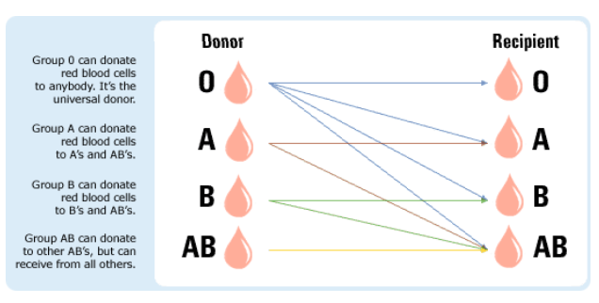
Inheritance of Blood Type

Possible blood type results for offspring:
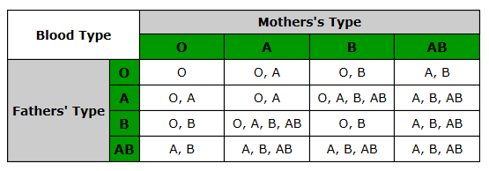
By Mary Ann Yeung MT(ASCP)SBB, 281-274-7041, mayeung@houstonmethodist.org

